**Project Choice**

FullStack Car Club

<https://fullstack-car-club.herokuapp.com/vehicles>

**Project Description**

Include:

App for car club members to access information on cars in the club and rent them out

The models (index.js) will include model, year, type, description, and availability for rental

A list of routes:

1. GET /vehicles to index.ejs,

2. GET /vehicles/:id to show.ejs,

3. GET /vehicles/new to new.ejs for entering new cars,

4. POST creates vehicle object redirects to /vehicles,

5. GET /vehicles/:id/edit to change vehicle information,

6. PUT updates vehicle objects and redirects to /vehicles,

7. DELETE /vehicles/:id removes vehicle object and redirects to /vehicles

**Wireframes**

Wireframes with basic page layouts

Each catagory (i.e. "Classics") will have a feature page of a vehicle of that type

Every vehicle will have a show/edit page

Each account will have a user page

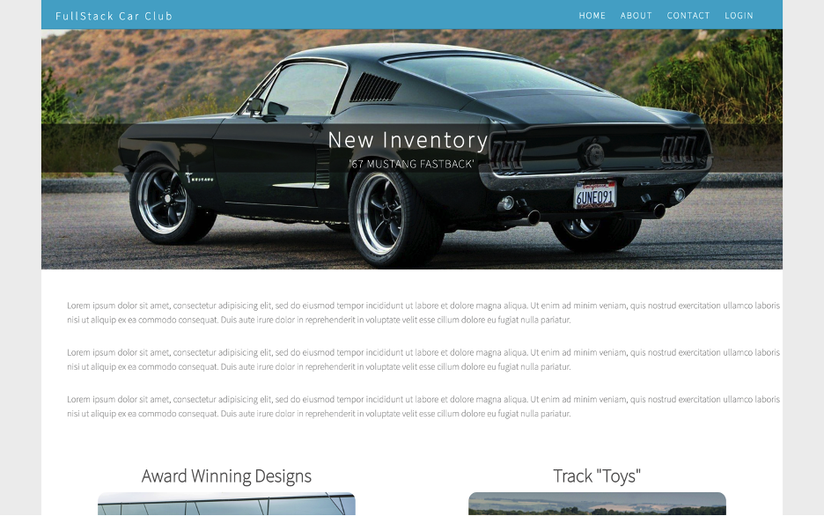

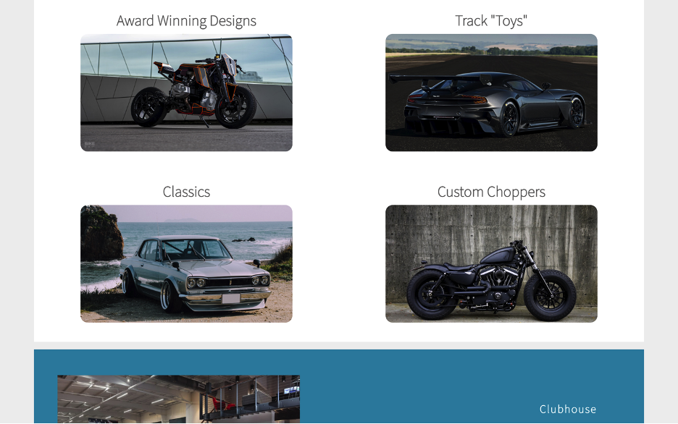

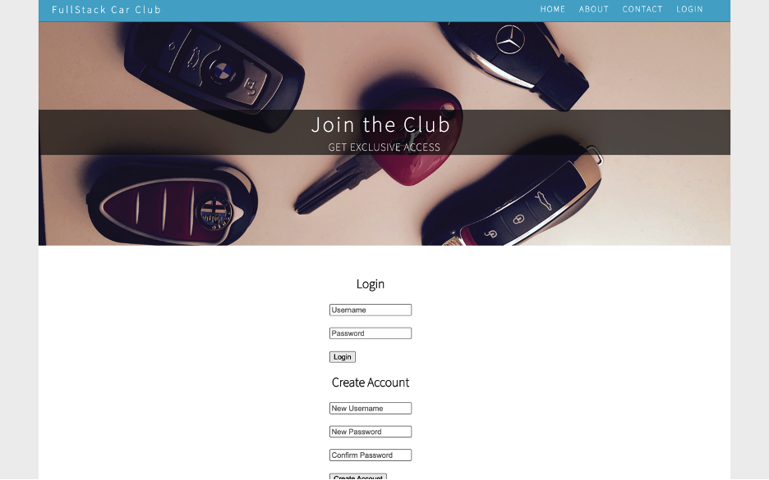

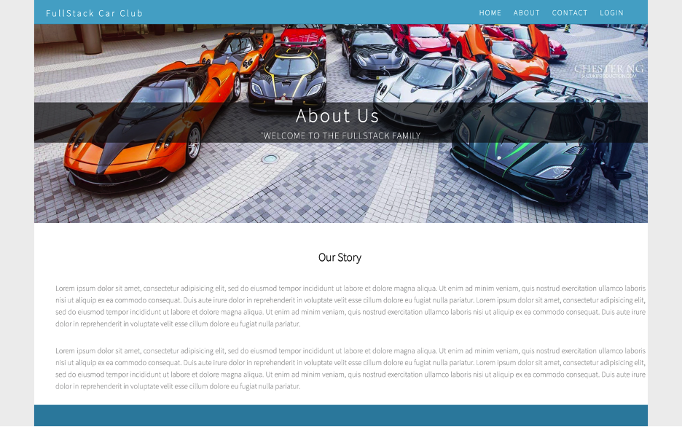

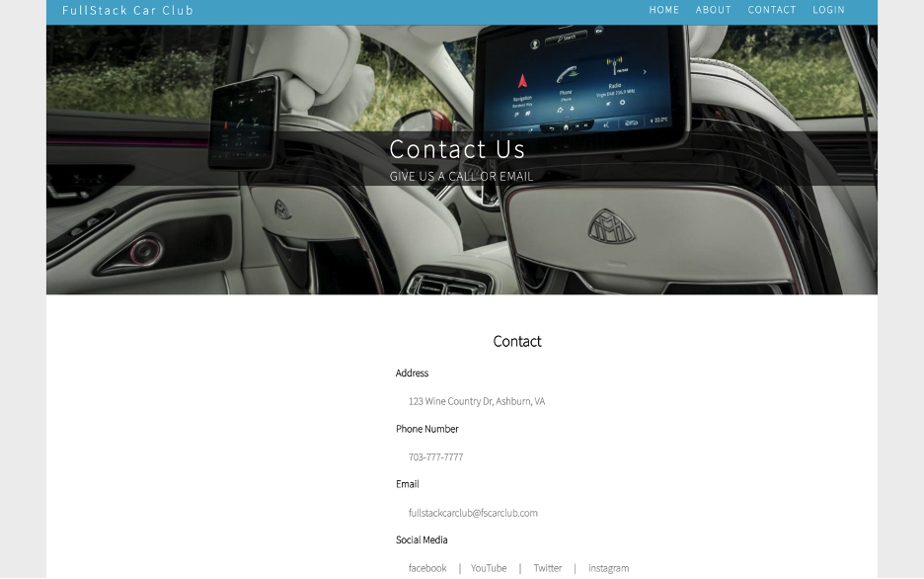**User Stories**

User stories detailing app functionality

As a car enthusiast, I want to access to a database of exotic cars, so that I learn more about current and future cars

As a car collector, I want online access to my cars location and use, so that I maintain my collection

As a car club member, I want access to all the club cars , so that I can add my own vehicles and rent other members'

As a car enthusiast, I want to access to automotive events, so that I can meet more people with similar interests

**MVP Goals**

Ability to create, edit, and delete cars in the club database

Full database functionality

Access to a basic account

User friendly site with balanced CSS

**Stretch Goals**

Google Maps plugin

Email interaction